GSE Algebra II Name____________________________________
Unit: 7 | Homework: 7
Standard:
Summarize, represent, and interpret data on a single count or measurement variable
MCC9-12.S.ID.4 Use the mean and standard deviation of a data set to fit it to a normal distribution and to estimate population percentages. Recognize that there are data sets for which such procedure is not appropriate. Use calculators, spreadsheets, and tables to estimate areas under the normal curve.
Essential Question: How is discrete data different from continuous data? How can you tell if a set of values is normally distributed?
Key Words: continuous data, discrete data, normal distribution, normal curve, symmetric distribution, uniform distribution, probability distribution, random variable, Empirical Rule
500 juniors at Central High School took the ACT last year. The scores were distributed normally
with a mean of 24 and a standard deviation of 4. Label the mean and three standard deviations from
the mean.
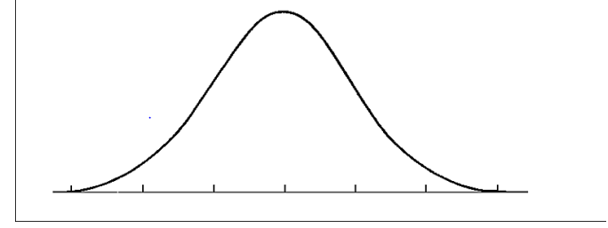

Answer the following questions based on the data:
- What percentage of scores are between scores 20 and 28? ______________
- What percentage of scores are between scores 16 and 32?_______________
- What percentage of scores are between scores 16 and 28?_______________
- What percentage of scores is less than a score of 12?___________________
- What percentage of scores is greater than a score of 24?_________________
- Approximately how many juniors scored between 24 and 28?______________
- Approximately how many juniors scored between 20 and 28?_____________
- Approximately how many juniors scored between 24 and 32?______________
- Approximately how many juniors scored between 16 and 20?_______________
- Approximately how many juniors scored higher than 32?___________________

500 freshmen at Hiram High School took an algebra test. The scores were distributed normally
with a mean of 75 and a standard deviation of 7. Label the mean and three standard deviations from
the mean.
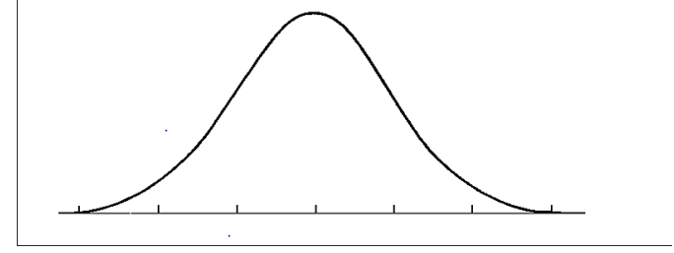
- What percentage of scores are between scores 61 and 82?______________
- What percentage of scores are between scores 75 and 82?______________
- What percentage of scores are between scores 61 and 89?______________
- What percentage of scores is less than a score of 61?__________________
- What percentage of scores is greater than a score of 96?_______________
- Approximately how many algebra students scored between 61 and 89?_______________
- Approximately how many algebra students scored between 68 and 82?________________
- Approximately how many algebra students scored between 61 and 75?_________________
- Approximately how many algebra students scored between 89 and 96?_________________
- Approximately how many algebra students scored higher than 89?_____________________

