GSE Algebra II Name____________________________________
Unit: 7 | Homework: 5
Standard:
Summarize, represent, and interpret data on a single count or measurement variable
MCC9-12.S.ID.4 Use the mean and standard deviation of a data set to fit it to a normal distribution and to estimate population percentages. Recognize that there are data sets for which such procedure is not appropriate. Use calculators, spreadsheets, and tables to estimate areas under the normal curve.
Essential Question: How is discrete data different from continuous data? How can you tell if a set of values is normally distributed?
Key Words: continuous data, discrete data, normal distribution, normal curve, symmetric distribution, uniform distribution, probability distribution, random variable, Empirical Rule
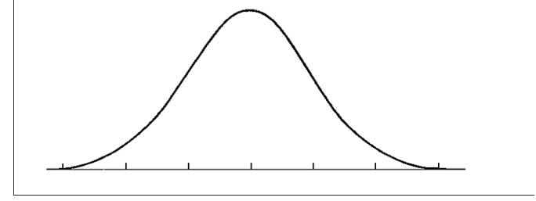
In a normal distribution, what percent of the values lie:
1. below the mean? ____________ 2. above the mean? ____________

3. within one standard deviation of the mean? ____________

4. within two standard deviations of the mean? ____________

5. within three standard deviations of the mean? ____________
6. 2000 freshmen at State University took a biology test. The scores were distributed normally with a
mean of 70 and a standard deviation of 5. Label the mean and three standard deviations from the
mean.
Answer the following questions based on the data:
a) What percentage of scores are between scores 65 and 75? _____________

b) What percentage of scores are between scores 60 and 70?_____________

c) What percentage of scores are between scores 60 and 85?______________

d) What percentage of scores is less than a score of 55?__________________

e) What percentage of scores is greater than a score of 80?________________

f) Approximately how many biology students scored between 60 and 70?_______________

g) Approximately how many biology students scored between 55 and 60?______________

