CCGPS Advanced Algebra .Name____________________________________
Unit: 5 | Homework: 8
Standard: Build new functions from existing functions
MGSE9-12.F.BF.5 (+) Understand the inverse relationship between exponents and logarithms and use this relationship to solve problems involving logarithms and exponents.
Essential Questions: How do I graph a logarithmic function?
Key Words: logarithm, common logarithm, logarithmic function, vertical asymptote, domain, intercepts
Unit: 5 | Test: 1 REVIEW
1. p(x) = -1.5(2)^{x}  a. Graph  Domain:__________ Range:____________  x-int:____________ Y-int:______________  Asymptote___________________________  Increasing or Decreasing  End Behavior | 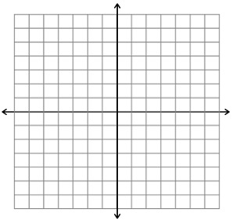

2. In 2000, a city had a population of 12.2 million and was increasing at a rate of 1.65% each year.

a. Write a function for the population of the city.

b. Does the function represent growth or decay?

c. Use a graph to predict the population in 2015.

3. Write each exponential expression as a logarithm or an exponential expression
a. $2^{4}=16$

b. log₅ 125 = 3
4. Evaluate each expression using mental math.

- log₈ 512

- log₆ 6⁵

- log₂ (1/16)
5. Solve each logarithmic equation for x.

a. log_{x} 27 = -3

b. log₄ 256 = x
6. Solve each of the following for x using common logarithms. Show your work!

a. 10^{x} = 43

b. 2 (10^{x}) = 3410

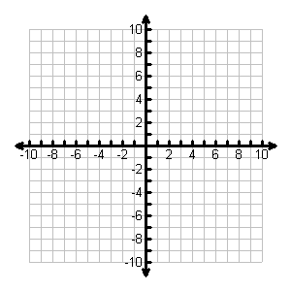
7. f(x) = log₂(x – 2) – 1
a. graph f(x)

b. domain of g(x)_______________ c. range of g(x)_______________

d. asymptote(s) of g(x)__________________

e. intercept(s) of g(x)________________

f. Is the function increasing or decreasing? ________________

8. Use the given x-values to graph the function. Then graph its inverse.  f (x) = 0.1 ^{x}; x = −1, 0, 1, 2 | 