Algebra II Name____________________________________
Unit: 5 | Homework: 3
Standard: Analyze functions using different representations
- MGSE9-12.F.IF.7 Graph functions expressed algebraically and show key features of the graph both by hand and by using technology.
- MGSE9‐12.F.IF.7e Graph exponential and logarithmic functions, showing intercepts and end behavior.
Essential Questions: How can equations describe growth and decay situations?
Key Words: exponential function, logarithmic function, inverse function, logarithm , base, asymptote, exponential growth, exponential decay
Use the function f (x) = 3 ^{x}.
1. Does the function show exponential growth or decay? Explain.
Is f (4) greater than or less than f (3)? Explain how you can draw this conclusion.
2. Kyle estimates that his business is growing at a rate of 5% per year. His profits in 2005 were $67,000.
Estimate his profits for 2010 to the nearest hundred dollars.
Use the function f (x) = 0.4^{x} .
3. Does the function show exponential growth or decay? Explain.
Is f (-3) greater than or less than f (- 2)? Explain how you can draw this conclusion.
4. Colleen’s station wagon is depreciating at a rate of 9% per year. She paid $24,500 for it in 2002. What will the car be worth in 2008 to the nearest hundred dollars?
5. A parcel of land Jason bought in 2000 for  $100,000 is appreciating in value at a rate of  about 4% each year.  a. Write a function to model the appreciation  of the value of the land.  b. Graph the function.  c. In what year will the land double its value? | 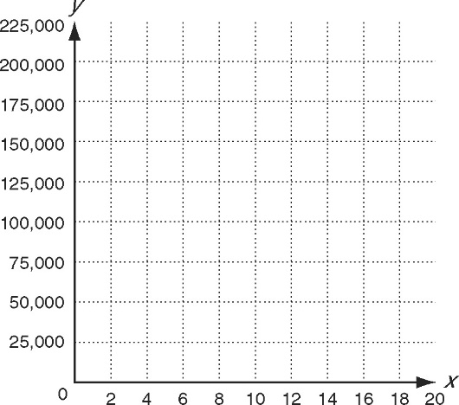  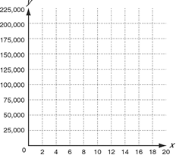
6. A certain car depreciates about 15% each year.  a. Write a function to model the depreciation  in value for a car valued at $20,000.  b. Graph the function. | 