Algebra II Name____________________________________
Unit: 5 | Homework: 2
Standard: Analyze functions using different representations
- MGSE9-12.F.IF.7 Graph functions expressed algebraically and show key features of the graph both by hand and by using technology.
- MGSE9‐12.F.IF.7e Graph exponential and logarithmic functions, showing intercepts and end behavior.
Essential Questions: How can equations describe growth and decay situations?
Key Words: exponential function, logarithmic function, inverse function, logarithm , base, asymptote, exponential growth, exponential decay
1. When the base in an exponential function is between 0  and 1, the function shows ________________________? | 2. Tell whether the function shows growth or decay.  a) b) 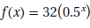
3. The amount of freight transported by rail in the United States was about 580 billion ton-miles in 1960 and has been increasing at a rate of 2.32% per year since then.
a) Write a function representing the amount of freight, in billions of ton-miles, transported annually (1960 = year 0).  c) In what year would you predict that the number of  ton-miles would have exceeded or would exceed 1 trillion (1000 billion)? | b)
4. Radon-222 is a gas that escapes from rocks and soil. It can accumulate in buildings and can be dangerous for people who breathe it. Radon-222 decays to polonium and eventually to lead.  a) Find the percent decrease in the amount of radon-222 each day.  b) Write an exponential decay function for the amount of a 500 mg sample of radon-222 remaining after t days.  c) How much of the radon-222 sample would remain after 14 days? | 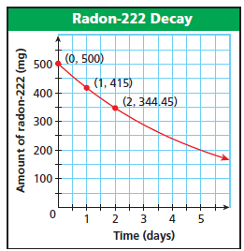
5. How can the function $f\left(x\right)={16}^{\frac{x}{8}}$ be rewritten so that the exponential term has a base of 4? | 6. For the function $p\left(x\right)={2.89}^{x/2}$, by what percentage does p(x) change as x increases from 0 to 1? Does this function model exponential growth or exponential decay?

