GSE Algebra 2 Unit 4: Rational and Radical Relationships
Name____________________________________ Date_____________________

Unit: 4B | Test Review
- Solve the rational equation  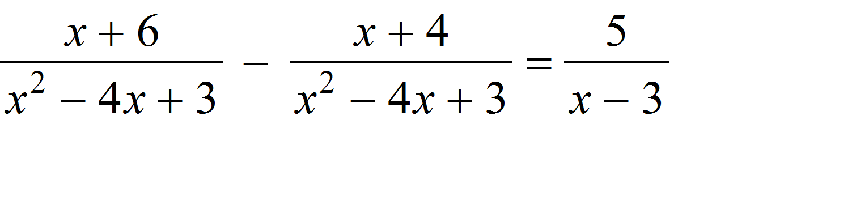 | - Solve the rational equation  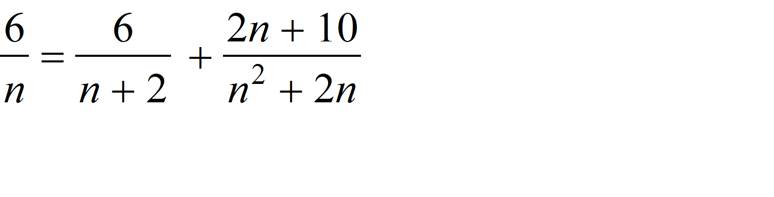
- Kent can paint a certain room in 6 hours, but Kendra needs 4 hours to paint same room. How long does it take then to paint the room if they work together.? | - Marco can build a lap top twice as fast as Cliff. Working together, it takes them 5 hours How long would it have taken Marco working alone?
- Write a rational function of the form that has the given vertical asymptote(s) and zero(s): zero of x = 1; undefined at x = 3 | - Write a rational function of the form that has the given vertical asymptote(s) and zero(s): vertical asymptotes at x = 1 and x = -2; zero at x = 3
- Sketch the graph of the given rational function on a coordinate plane. Include asymptotes and zeros, if any.  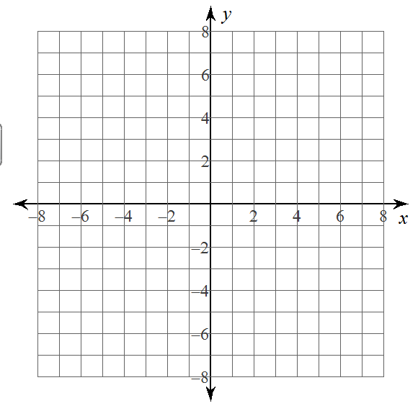 | - Sketch the graph of the given rational function on a coordinate plane. Include asymptotes and zeros, if any. $f\left(x\right)= \frac{4x-1}{2x+1}$
- Find the zero(s) of each rational function  $$f\left(x\right)= \frac{x^{2}-2x-3}{x+1}$$ | - Find the zero(s) of each rational function  $$f\left(x\right)=\frac{x^{3}-4x}{x-2}$$
- For the following functions find the properties of the function: x-intercept or zero, y-intercept, vertical asymptote and the horizontal asymptote.  x-int:____________(write as an ordered pair)  y-int: :____________(write as an ordered pair)  Vert asy:____________________  Horz asy:_____________________ | - For the function below find the x-intercept, the y intercept, the vertical asymptote and the horizontal asymptote.  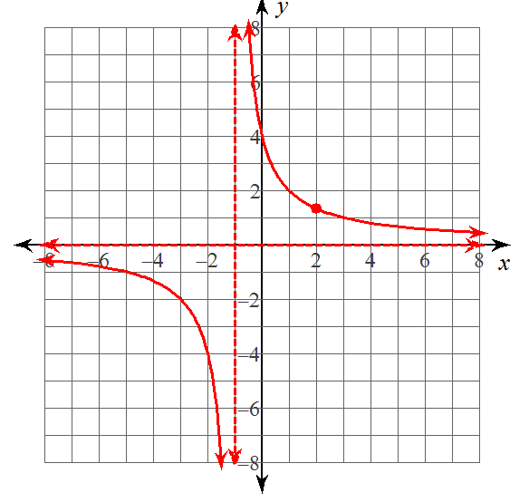  x-int:____________(write as an ordered pair)  y-int: :____________(write as an ordered pair)  Vert asy:____________________  Horz asy:_____________________  Write the equation for the graph:________________

