CCGPS Advanced Algebra Name____________________________________
Unit: 2 | Homework: 7
Standard: Build new functions from existing functions
MGSE9-12.F.BF.4 Find inverse functions.
MGSE9-12.F.BF.4b Verify by composition that one function is the inverse of another.
MGSE9-12.F.BF.4c Read values of an inverse function from a graph or table, given that the function has an inverse.
Essential Questions: How can I determine the inverse of a polynomial function?
Key Words: polynomial function, function composition, inverse function
For #1-2, complete the table for the given function. Then use the table to graph the function with a solid line and the INVERSE of the function with a dashed line.
x f(x)  ⁻⁵  ⁻⁴  ⁻³  ⁻²  ⁻¹  ⁰  ¹  ²  ³  ⁴  ⁵  1. f(x) = 2x + 1  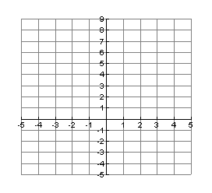 | x f(x)  ⁻⁵  ⁻⁴  ⁻³  ⁻²  ⁻¹  ⁰  ¹  ²  ³  ⁴  ⁵  1. f(x) = -3x + 2
For #3-6, find the inverse of each function. $f^{-1}(x)$
3. $f\left(x\right)=5x+1$ | 4. $f\left(x\right)=-2x+4$
5. $f\left(x\right)=\frac{2}{3}x-2$ | 6. $f\left(x\right)=\frac{4}{3}x+3$
For #7-8, use function composition to determine if $f(x)$ and $g(x)$ are inverses.
7. $f\left(x\right)=3x+5, g\left(x\right)= \frac{1}{3}x-\frac{5}{3}$ | 8. $f\left(x\right)=2x+3, g\left(x\right)= -2x-3$

