Homework 14 Solving quadratic equation by the quadratic formula and factoring |  |  | Unit 1
Solve each equation by using the quadratic formula.
- 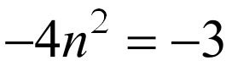 | - 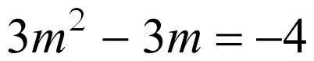 |  |  | - 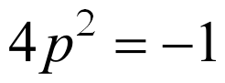
- 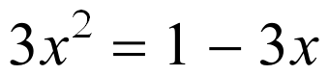 | - 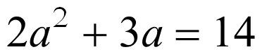 |  |  | - 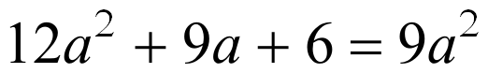
- 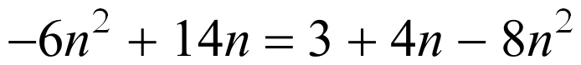 |  | - 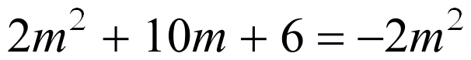
- 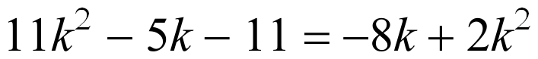 |  | - 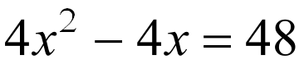
Solve each equation by factoring.
-      