Homework 13 Solving quadratic equation by taking square roots and completing the square |  |  | Unit 1
Solve each equation by taking square roots.
- 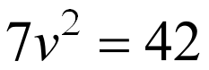 | - 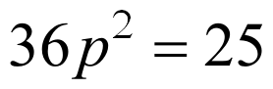 |  |  | - 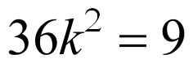
- 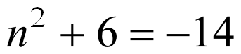 | - 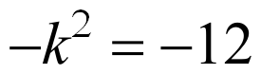 |  |  | - 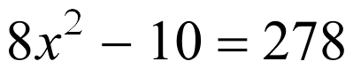
- 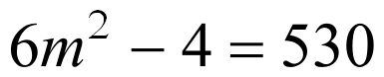 |  | - 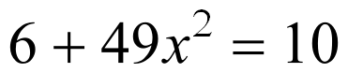
- 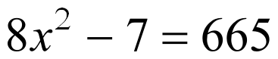 |  | - 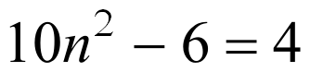
Solve each equation by completing the square.
-      