**Guided Reading for Exponential Graphs and Applications Name:**

***x f(x)***

***-15***

***x f(x)***

***-3***

***-2***

***-1***

***0***

***1***

***2***

1. A function of the form *f*(*x*) = *abx* is called an exponential ____________________ function when *b* is greater than 1.
2. A function of the form *f*(*x*) = *abx* is called an exponential ____________________ function when *b* is between 0 and 1.

Which one is growth and which one is decay?

$1*{\left(\frac{2}{3}\right)}^{x}=y$ $1*{\left(\frac{3}{2}\right)}^{x}=y$

2. Tell whether the function shows growth or decay. Then graph.

f (*x*) = 3 (2.5 )*x*

a. Find the value of the base. ________

b. Does the function show growth or decay? ____________

c. Make a table of values for the function.

d. Graph the function

. 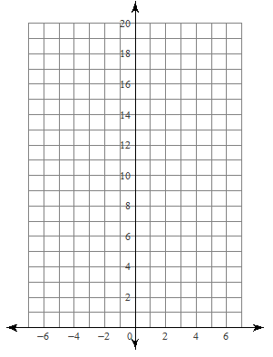

Go to your notes and find the answer on page 2. Pay attention to the boxes in the middle of the page.

In problem 3: What is b = ? What would that look like as a decimal?

In problem 4: Identify a, b. What is ALL WAYS inside of the ( )?

a=_______________ b=_____________________

What is the lowest number the graph will reach? (smallest y value). Plug some x values in and experiment. Try some numbers that are far to the left of the graph. For example, plug in -15. What do you get for a y value? You choose 3 more numbers further to the left than -15.

What number does it seem that y might become? ___________________

1. Some real estate agents estimate that the value of a house could increase about 4% each year. You bought your house for $100,000 in 2000.

a. Write a function to model the growth in value your house.

b. Graph the function.

c. A house is valued at $100,000 in 2005. Predict   
the year its value will be at least $130,000.

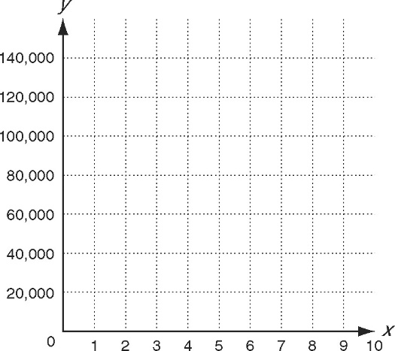

Need an example? Go to page 5 in the notes. -The top of the page is a problem like this one.

Part a

Line 1: Is there anything important in this line?

Line 2: Circle the initial amount in the problem number 5

Line 2: Put a box around the rate. Convert the rate to a decimal (divide by 100).

Line 2: What word means growth or decay? Underline the word. Will you need (1+r) or (1-r)?

Part b

|  |  |
| --- | --- |
| x | y |
| 0 |  |
| 1 |  |
| 2 |  |
| 3 |  |
| 4 |  |
| 5 |  |
| 6 |  |
| 7 |  |
| 8 |  |

Part c

Look at your graph. Draw a horizontal line half-way between 140,000 and 120,000. This line represents 130,000. Circle where your graph touches the line. What is the approximate x-value? _______________

Add the x-value to 2000. ______________